Shotton Hall Primary School
Working together to
S H I N E
Successful, Happy, Inspired and Nurtured towards Excellence Monday 29th June

Good Morning Boys and Girls! I hope you’ve had a lovely weekend?

What day of the week is it today? Sing our ‘Days of the week song’ Can you think of other words that start with the same ‘m’ sound?

What is our new season now and what is the weather like?
We will continue with our beach themed learning this week…
Support your child to look at and discuss ‘animals under the sea’ within the supporting information of the home learning.

Today’s rhyme: Five Little Mermaids
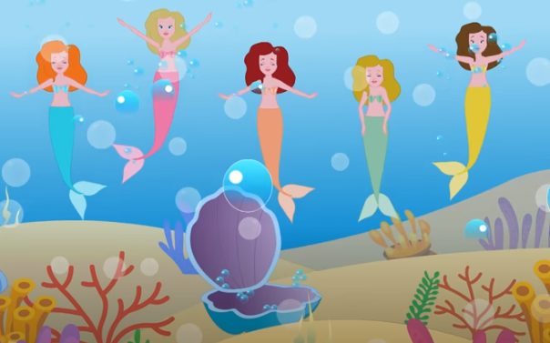
Practise and join in to this action song by using fingers and matching movements to the mermaids.

https://www.youtube.com/watch?v=yZsZUDycFp0

Challenge!

Practise writing the numerals 0-5 then beyond using correct number formation by starting at the red dot and following the arrow and using ‘Froggy Fingers’ pencil grip. Alternatively, if you are lucky enough to visit the beach, can you make the numbers using small pebbles?

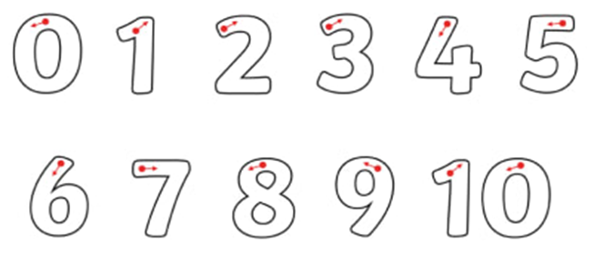

Art: Making Mermaids

- Support your child and paint the sole of their feet (one at a time) to imprint onto white card or paper using bright coloured paint. Hand paint the fish tail ‘V’ at the bottom of the heel print. Leave to dry.
- Leave a gap above the toes then using pale pink/flesh coloured paint to imprint the palm of hand. Join the palm print to the toes using the same paint to form a body. Hand paint 2 arms. Leave to dry.
- Decorate the fish tail with fingerprints to add ‘scales’.
- Use paint and imprint fingers for ‘hair’ on top or at the side. Leave to dry.
- Cut out using ‘careful cutting’.
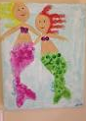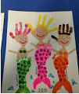

Don’t forget to share with Mrs Caden and Mrs Smith what you have enjoyed in your learning today!
Storytime: The Little Mermaid

This story finishes our making and learning today perfectly!
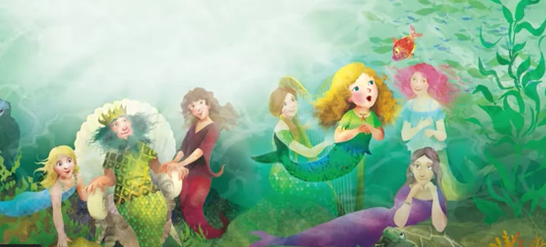Read, share and enjoy this story.
Hope you enjoyed making your mermaid or merman too:

https://www.youtube.com/watch?v=NMOHIscNju0

